Your Personal Training Pack provided by . . .


Tel. 01302 822307 or call in at 5 Jossey Lane, Bentley, Doncaster

A HUGE WELCOME

From all at Doncaster Athletic Club to the new

‘Doncaster Pacers’ group

Congratulations you have just made the first steps on the road to a life-changing venture.

With committing to join the Pacer’s you can look forward to enhanced fitness and health, access to coaching, training, nutritional advice as well as information on injury prevention and management.

In addition you will meet new friends and fellow runners and the opportunity to join in on the many social events that the Pacer’s and DAC members are involved in throughout the year.

This information pack contains advice on training, tips for improvement, managing your training runs and mileage, nutritional advice, how to prevent and manage injuries in order to help you balance your lifestyle, work commitments and training effectively and successfully

Keep this pack handy and use it as you progress with your training. I hope you find the contents helpful and are able to use the information to guide you from the very start and throughout the future of your running . . .

“Now that you have taken the first steps, the future is yours for the taking and yours to shape”

Firsts Steps - Being prepared for your new venture

Many of you will be new to running or only ever done a small amount of running so it is essential that you follow a few basic rules and use the following tips to help you progress and achieve your goals.

Your coaches will be your main source of general advice and info, they have been on run trainer/coaching courses and many have a vast amount of experience and knowledge. They will get you started with all the right advice from the beginning and continue to support you throughout your venture.

Also, many of the other more experienced runners down at the club will be only too glad to offer and give you good advice. More in-depth knowledge can come from running forums, running magazines and the classroom talks and forums that the club lays on periodically free of charge for you.

Initially though, here is some basic all round advice to get you started on the right track – this advice will be covered in more detail in the relevant sections in this pack:-

Wear the right clothing for the weather conditions:-
Remember, you can always take an item off and tie it around your waist if you get too hot - but you can’t gear up if the weather takes a turn for the worse and you don’t have the extra item to put on.

Wear trainers designed specifically for running:-
There is more detailed advice on this topic in the section ‘Get the Gear’ further on in this pack

Warm up and warm down:-
Cold muscles are easily injured, getting them warmed and the blood circulating to them is essential prior to running and easing down after can help your body come down - especially after a hard workout.

Stretch:-
Gently stretch your muscles before and after your workout. There are two schools of thought about this but as long as you stretch gently and correctly it is safe and will enhance your training and recovery (more on this in the ‘training’ and ‘injury prevention’ section)

Do not be in too much of a hurry to progress:-
Don’t increase your mileage or pace too quickly. The body will adapt and respond to training best with a gradual progression. Some basic tips to adhere to are as follows:-

  - Follow the 10% rule – this is where you would not increase your weekly mileage from one week to the next by more than 10% in order to prevent injury. This 10% rule should also apply when increasing your long runs from week to week.

  - Listen to your body - if you are picking up little niggles or injuries all the time or seem to be feeling run down or fatigued, act on this early (see next section on ‘injury prevention and management’)

  - Do not enter too many races – don’t over stress your body before it is ready by racing too often and don’t be tempted to enter races that are longer than you can safely manage or have not adequately prepared for (more details in the ‘training’ and ‘injury prevention’ section)

Remember, don’t just train hard – train Smart

Starting out with the basics . . .

Get The Gear:-

What do we need to start running, very little really - basically a pair of trainers, shorts and a top will suffice.

For the colder months of course, a base layer, a water proof/wind proof jacket, running tights or leggings and a hat and gloves are essential to keep the elements out and the muscles warm.

A little about trainers though, most of us own a pair for the gym or just for general use but as you get into your running, a pair of trainers made specifically for running is essential once we start pounding the pavements and begin to progress our mileage and increase the time we spend training.

There is however such an array of different brands, as well as trainers designed for different running styles, the way your foot strikes the ground etc, but don’t get too hung up on this. Your coaches and the more experienced runners can give you basic advice on this, where to buy, how much to pay etc.

For more detailed advice there are many specialist running shops and articles in fitness and running magazines that can guide you in the right direction. Alternatively, have a chat with me down at the club. I specialise in sports injuries and have had advanced training in gait analysis and foot biomechanics and will give you free advice and a free assessment of your foot strike and type of shoe that will best suit your needs and so prevent unnecessary injuries.

Just give me a shout on training nights or ask one of your coaches to point me out – we need to get you off on the right foot so to speak!

Other gear you might consider at some point might include Hi-Vis clothing, this could be anything from a full reflective jacket to reflective strips or LEDs attached to your sleeve.

In the summertime, a pair of sports sunglasses can help protect your eyes from the sunlight and also from insects and flies etc.! These won’t help you swallowing a few of course – but you could see this as extra protein on the run!!!

Sports watches and more specialist gadgets like Garmin GPS devices are great for recording all your running statistics like pace per mile, distance run etc. and even your heart rate. Most mobile phones however have apps that you can download and allow you to record similar things, ie, Strava, Run keeper, Map my run etc. to name but a few – most of them free or for a small download fee of a few pounds.

Some other optional items may include:- Sports socks, sweat bands, head bands, bandanas, running water bottles, running belts, compression clothing, technical clothing etc, and are really down to individual preference.

Don’t forget the sports bra ladies – essential for comfort and support and can make a big difference to helping you run with better form and more efficiently. This item of attire is optional for the men!

Basic Training Principles

In basic terms, you need to include 3 types of workouts in your training schedule each week in order for you to steadily improve and these are outlined below:-

THE LONG RUN
A regular run where the distance is steadily increased up-to your chosen level or to prepare you for a future race. These should be done weekly or at least fortnightly depending on experience, susceptibility to injury etc. Long runs should be done at your BASE PACE.

Base pace is your steady running pace, 90 seconds to 2 minutes per mile slower than your recent 10k race pace is a good estimate. Don’t worry if you have no race times to work from yet, you can use the run/talk principle. This is where you can run along and talk/chat to your fellow runners comfortably and so will give a good indication of your base pace.

  - These runs will improve your stamina and ability to train for longer periods.

QUALITY SESSIONS
These are workouts done at an increased pace and/or effort and include, speed sessions such as repetitions, pickups and fartlek, hill running and tempo runs. Your coaches will introduce these into your training steadily and encourage you to work a littler harder as you improve.

These runs will make you stronger, quicker and a more efficient runner

RECOVERY RUNS
Often neglected by runners, especially the experienced, but these runs are an important, if not the most important ingredient in your training schedule as they allow your body to recover and “train up” between your harder workouts and long runs.

A rule of thumb is that you should allow at least one but preferably two days of either complete rest or recovery runs between the harder sessions. It is important that these runs are kept at base pace.

  - These runs and recovery sessions will allow you to recover and be able to handle the harder sessions - it is during this time that your body adapts to the stresses of your other training and improvement takes place



Injury prevention and management

Remember the 10% rule – do not increase your weekly mileage by more than 10% from one week to the next and your long run should not increase from one week to the next by more than 10%

Always warm up gently for at least 10 minutes. This will raise your heart and breathing rates and get the circulation going to supply blood and nutrients to the working muscles. The rule of thumb is the further you intend to run, the longer your warm up should be. Always warm down gently to allow your heart rate to come down slowly and prevent the possibility of blood pooling in your legs with the possibility of making you feel faint.

Stretch regularly before and after training, as long as this is done gently and correctly and when muscles are warm, this is safe. Stretching can prevent pulls and injuries from tight muscles before training and help fatigued muscles recover afterwards. I have provided some good stretches for the major lower limb muscles for you to use (with instructions for performing them correctly with good technique) at the end of this section.

Make sure you fuel and hydrate your body adequately (more detail on this in the Nutrition section)

Progress steadily, the cardio-vascular system improves quicker than the musculo-skeletal system and if we are in too much of a hurry to increase speed and distance or race too often we will break down and injure. Too much, too soon too fast is a recipe for disaster and many weeks and months can be lost through injury this way. If you are picking up little niggles, getting injured often or regularly getting run down and feeling tired, act quickly. Back off from your training mileage, have a few days off – do some gentle cross training. Ease back into your training at a lower level and then build back up gradually.

Ice the area initially- usually for the first 48-72 hours, Take a short course of anti-inflammatory tablets (Ibuprofen or Nurofen) if you are ok taking these (check with your chemist or GP if you are unsure) and begin some early, gentle stretching of the affected area and surrounding muscles.

Learn from the experience, it takes many years to build your musculo-skeletal system up to handle the rigours of running and the more steady miles you put in the bank - the more your body can safely handle and this will improve over time.

If your injury persists or is stopping you running or progressing, this is when to seek professional help, I am always available to the runners down at the club for some informal advice or give me a ring (leave a message on the Clinic answer phone with your contact details if I am not available) or message me on facebook through the Pacer’s site and I will get back to you ASAP with friendly advice.

If your injury is more serious and you do need an appointment, I can assess, diagnose and treat the problem quickly and effectively to get you back to training as soon as possible. I specialise in Musculo-skeletal physiotherapy and sports injuries and have over 12 years experience as a senior level physiotherapist in this field, so rest assured you are in safe hands.

My clinic is in located in Bentley and is equipped with the latest cutting edge equipment including ultra-sound, therapeutic laser, interferential and Gyratory massage units. Also on-site, there is a fully equipped gym with the latest professional equipment to provide complete cardio-vascular, resistance training and rehabilitation facilities to maximise and compliment your recovery.

Basic Stretches for the major leg muscles

Always gently ease into the stretches to feel a gentle stretch in the muscle, then hold the stretch for 20 seconds – relax off and repeat 2 more times for a maximum of 3 stretches for each of the muscle groups on both legs. As you become more flexible you can ease a little further into the stretches to progress.
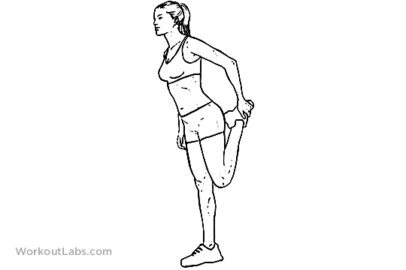
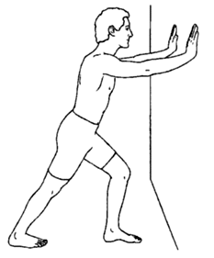

Calf stretch: Put one leg behind you with the heel on the floor and knee straight, then gently lean forward at the hips to feel the stretch in the calf of the leg behind
Quadriceps stretch: Gently bring the leg up behind and towards your buttock. Keep the pelvis forward to feel a stretch in the front of the thigh.
Hold on to something with the other hand if needed

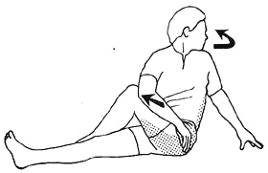


Gluteal/Hip stretch: Cross one leg over the other and rotate away using the arm to gently push the hip a little further over to feel the stretch behind your hip
Groin stretch: Sit on the floor with the soles of feet and together and gently push your knees apart with your forearms to feel the stretch in your inner thighs and groin muscles

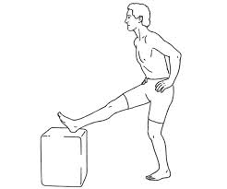

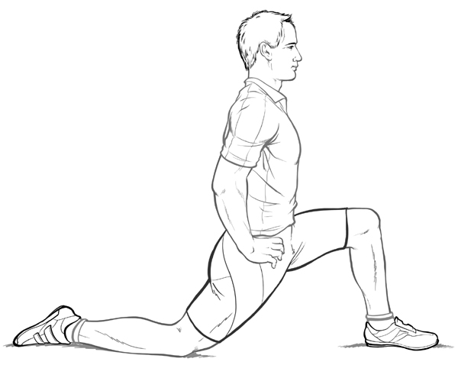

Hamstring stretch: Put your foot on to a chair or step and keeping your knee straight, gently ease your hips forward to feel the stretch down the back or the leg
Hip flexor stretch: kneeling on one leg, gently ease your hips forward to feel the stretch in the thigh of the leg behind and also in the buttock of the other leg

Nutrition and Hydration Guide

Now you are training your body you need to focus a little more on how to fuel and hydrate properly. Your body needs certain requirements in order to perform at it’s best and also to recover and repair well.

In order to do this we need to eat sensibly and healthily. The answer is not crash diets or quick fixes, if you are eating the right types of food in sensible portions your training will increase your metabolism and burn those extra calories. This will enable you to achieve and maintain a healthy weight – remember calories are fuel and we need these for our workouts, we just need to make sure they are the right calories in the right proportions, the rest will take care of itself.

So what should a Runner’s diet consist of ? . . . below is a Graphic showing which type of foods and in what proportions we should include to ensure we are supplying the energy we need.

The Runner’s Plate



Lean Protein 10% to 30%

Carbohydrates 55% to 65%
Unsaturated Fats 20% to 30%

Carbohydrates 55%-65% Foods such as Pasta, Rice, Wholegrain breads, vegetables and fruits.

Lean Protein 10%-30% Foods such as Chicken, Fish, Eggs, Milk, Tofu and Soy Protein, Nuts and Seeds and lean cuts of Meat.

Unsaturated Fats 20%-30% Foods such as Olive Oil, walnuts, Avocados, Oily fish (Tuna, Mackerel, Sardines, Salmon and Anchovies).

Why these foods . . .

Carbohydrates . . .

These should form the backbone of your dietary needs because they provide the fuel for your workouts and replenish spent energy and nourish your muscles.

There are basically two types of Carbs - Slow carbs and Fast carbs.

You should make the slow type the main source of your carb intake because they deliver a long, slow release of energy and these are found in fruit and vegetables, grains, wholemeal pasta, wild or brown rice wholegrain breads etc,

There is a place for fast Carbohydrates though as these provide a faster release of energy and are great before a workout to give you energy for your run and also after a workout to quickly replenish your spent energy and restore the balance

These include, white rice, potatoes, cakes and sweets as well as foods that have been more refined including the slow type carbohydrates that have undergone processing.

Lean Protein . . .

Essential in your diet because your muscles are basically made of protein and proteins are the building blocks that repair damaged tissue. Protein also supplies some of your energy needs, is an essential nutrient and makes you feel fuller for longer.

Go for protein that is low in fat and cholesterol ie, lean meat, chicken, fish, low fat dairy products, whole grains and beans.

Unsaturated fats . . .

These should replace saturated fats in your diet whenever possible. Fats are essential to our dietary needs because they help the body to absorb certain nutrients, they are a source of energy and certain vitamins and they help regulate body temperature and protect and cushion vital organs.

Replace hard fats in your cooking for liquid oil such as olive oil or vegetable oil. Sources of unsaturated fats include nuts and seeds, oily fish and chicken and leaner cuts of red meat. Also certain vegetables and fruit especially avocados are all good sources to help provide you with your essential intake.

Do treat yourself to that glass of wine or dessert occasionally, this will satisfy the odd craving and prevent the urges from becoming binges! Just keep your eye on the portions and frequency.

When and What?

Remember, timing is everything before, during and after your workouts for both drinking and eating.

Here’s a quick guide:-

Before a short run, drink a glass of water in the hour before and eat around 200 calories of low fibre carbs about one hour or so before (ie, fig biscuits, cereal with skimmed milk, energy bars or a sports drink).

Before a long run it is better to drink a sports drink containing carbs and electrolytes about one hour before and eat around 350 - 500 calories a couple of hours before (same type of food as above but maybe include for example, a bagel with jam)

During your runs, if your run is going to be over one hour, take in 3 – 6 ounces of water or sports drink every 20 mins, Energy gels can also be ingested on longer runs to keep your energy levels topped up.

After a short run, drink 8 to 24 ounces of water within one hour of finishing (more in high temperatures or if running indoors on a treadmill). Eat a peanut butter sandwich or have a low fat chocolate milk drink, an energy bar or snack on pretzels.

After a long run, 8 to 24 ounces of water and again in high temperatures take in more and include a sports drink in these circumstances to replace the spent energy and the electrolytes and sodium lost through sweating. Try and eat a snack containing mainly carbs and a bit of protein within 15 to 20 mins of running and eat a proper meal around two hours after. Ham/tuna sandwiches, beans on toast, pasta or fruit smoothies with some added protein all provide ideal post run fuel.

Hydration basics

Plain water is good for runs lasting up to half an hour, if this gets boring try enhanced water, these are low calorie with a small amount of sweetener, vitamins and minerals but not enough to boost performance or replace these lost in longer runs.

Sports drinks come in a wide variety and these can help boost performance and replenish lost minerals and electrolytes as well as provide energy in the form of carbs. Good before, during and after your runs.

Endurance sports drinks contain the same as regular sports drinks but also contain extra electrolytes and sodium and are best for endurance runners or during runs of two hours or more. These can also help prevent cramps and are ideal if you sweat a lot during your runs.

Recovery drinks contain protein as well as carbs to help tissue repair and replenish your Glycogen (energy) stores. These are great after a race or hard workout and can sometimes be easier to face than solid foods after harder exertion.

Energy drinks are high in sugar and caffeine content and these can slow the absorption of fluids and can upset the stomach. They also contain various stimulants and on an empty stomach can cause you to feel shaky and may raise your blood pressure.

Soft drinks and juices are ok before a run but their dense carbohydrate concentration can slow down fluid absorption during a run and can unsettle the stomach in some runners.

The Final ‘Word’ (an array of inspirational quotes)

‘I don’t find the time to run, I make the time to run’

‘No matter how slow you are running
You are still lapping everyone on the couch’

‘Running is nothing more than a series of arguments between the part of your brain that wants to stop and the part that wants to keep going’

‘If you have Brains in your Head, if you have Feet in your Shoes,
You can Steer yourself in any Direction you choose’

‘Tough runs don’t last, tough runners do’

I WILL BEAT HER,

I will train harder,
I will eat cleaner,
I know her weaknesses,
I know her strengths,
I have lost to her before,
But not this time,
She is going down,
I have the advantage
Because I know her well,
She is the Old Me’

‘Remember it is Runners who will survive the Zombie Apocalypse’

